AI IN MEDICINE — COURSE PROJECT PROPOSAL
What Should Adaptive Cancer Therapy Optimise?
A controlled cross-evaluation of reinforcement-learning reward objectives
Team  Arnav Kumar MD24B003  Rohit Satish Chipde MD24B026 | Department  Medical Sciences & Technology (DoMST)  Indian Institute of Technology Madras

In one sentence
Six published reinforcement-learning studies of adaptive cancer therapy each optimise a different reward objective in its own bespoke simulator, and not one compares its objective against another; we port two of those objectives into a single shared environment, hold everything else fixed, and measure whether the choice of objective changes the treatment policy — and what it costs when it does.

1. Clinical problem
Most cancer deaths follow acquired drug resistance rather than a failure to shrink the tumour initially. Continuous maximum-tolerated-dose (MTD) therapy kills drug-sensitive cells quickly, but in doing so it removes the competitive pressure those cells exert on a pre-existing resistant subpopulation. The resistant clone is then released into an emptied niche and expands without restraint — competitive release, the dominant failure mode of systemic therapy.
Adaptive therapy inverts the goal. Rather than racing to eradicate the tumour, it withdraws or reduces the drug once the burden falls, deliberately retaining a pool of sensitive cells to suppress the resistant population, and reapplies the drug when the burden recovers. The tumour is contained rather than cured, and progression is deferred. This is not only a modelling proposition: in a prospective pilot in metastatic castrate-resistant prostate cancer, patients on an adaptive abiraterone schedule showed substantially extended time to progression on roughly half the cumulative drug of the standard continuous schedule (Zhang et al., 2017; follow-up in Zhang et al., 2022).
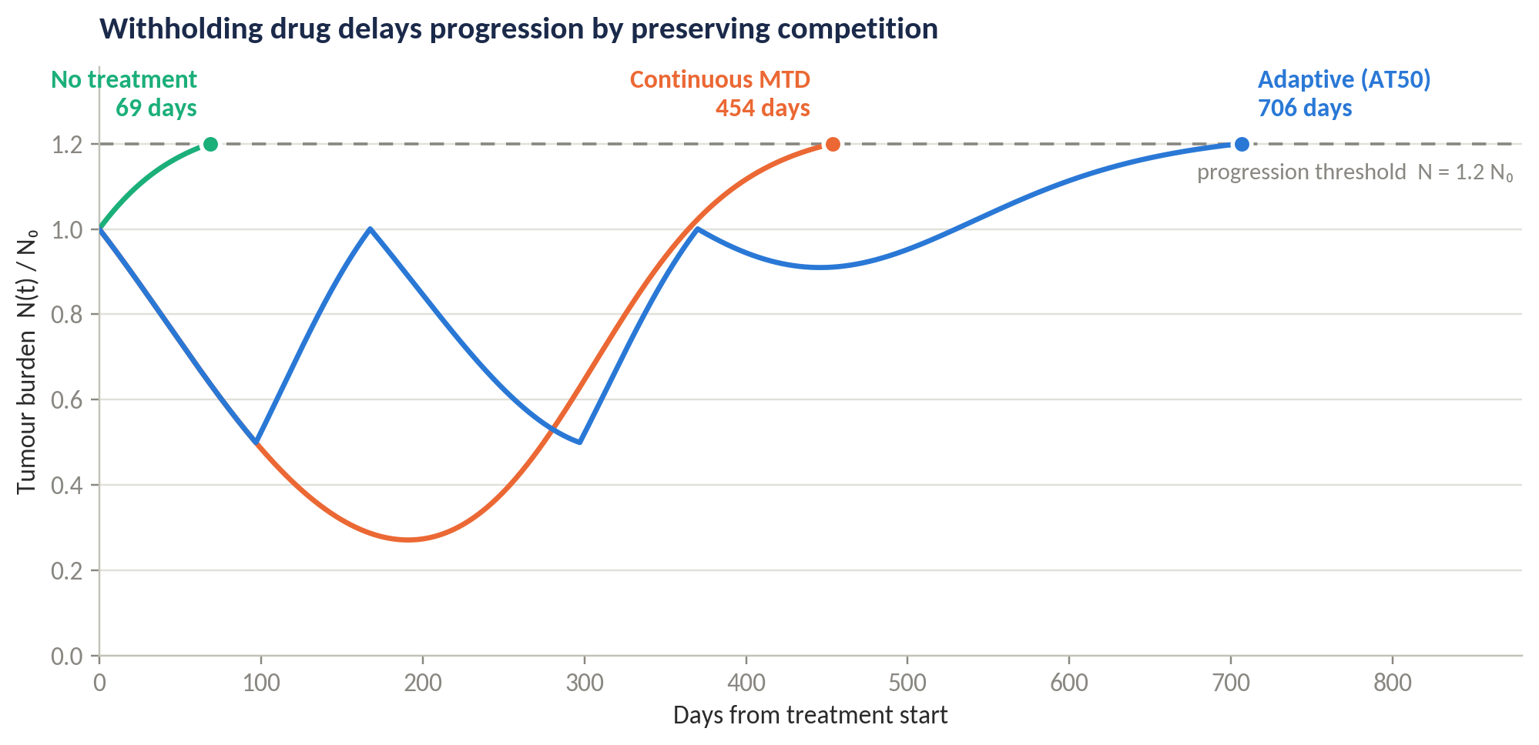
Figure 1. Our own re-implementation of the Strobl (2021) model. Continuous dosing drives the burden down fastest and progresses first; withholding drug preserves competition and defers progression. Simulated at cost of resistance 0.10, turnover 0.06.

2. Research problem and objective
An adaptive-therapy policy is only as good as the objective it was optimised for, and the field has quietly adopted several incompatible objectives without ever comparing them. Six studies in our corpus each optimise something different — survival time with a bonus for drug holidays, cumulative dose and treatment duration, population diversity or coexistence, post-withdrawal durability, inverse population fitness — and each evaluates its policy on its own chosen metric, in its own simulator. (Five of the six are reinforcement learning; Gluzman et al. solve the same class of problem by optimal control, which is why their objective belongs in the comparison even though their method does not.) The comparison has never been run.
This project asks a single question: does the choice of reward objective change the resulting treatment policy, and if so, by how much and at what cost on the objectives it was not trained for?
The reason the comparison is missing is structural rather than accidental. Each objective is welded to the environment it was written for. Shannon entropy over a three-population simplex is not the same quantity as entropy over two populations; a drug-holiday bonus is undefined in a fixed-population Moran process that has no tumour volume at all. Unwelding the objectives — porting them into one environment where they become commensurable — is the work, and it is why nobody has done it.

The contribution, stated honestly
This is a comparative and benchmarking contribution, not a new reinforcement-learning algorithm. We use PPO because it is a reliable, widely used policy-gradient method, and we deliberately do not claim it as the novelty. The novelty is the controlled comparison and the shared, correctness-verified environment that makes it possible.

3. Why this matters
If different objectives converge on substantially the same policy, then the field's reward-design discussion is decorative, and effort is better spent on environment realism — spatial structure, pharmacokinetics, measurement error. That is a useful and publishable negative result, and it is currently unavailable to anyone.
If instead the objectives diverge, then a clinician or modeller reading a published adaptive-therapy policy needs to know which objective it was optimised for before trusting its recommendation, because a policy tuned for maximal time to progression may be leaving the tumour in a far less controllable evolutionary state than one tuned for durability. Quantifying that off-diagonal penalty — what a clinician loses by optimising the wrong thing — is the number a translational reader actually wants, and no single-objective paper can produce it.

4. Simulation environment and data
No real patient dataset is used, and no patient-level records are accessed by us. The environment is the two-population Lotka-Volterra model with cell turnover introduced by Strobl et al. (2021), in the form Gallagher et al. (2023) write it. We choose it because four independent RL studies already build on it, so our numbers are directly comparable to published ones, and because its growth, turnover and competition parameters were fitted to a cohort of 67 real patients.
dS/dt = rS · S · (1 − (S+R)/K) · (1 − d̂D · D(t)) − dT · S
dR/dt = rR · R · (1 − (S+R)/K) − dT · R
N(t) = S(t) + R(t) , progression when N ≥ 1.2 N₀
S and R are the drug-sensitive and drug-resistant subpopulations, D(t) is the administered dose, and the kill term acts only on dividing sensitive cells (Norton-Simon). Resistance is taken to be pre-existing, binary and irreversible, and the cost of resistance is encoded as a reduced growth rate. These are assumptions to be stated rather than facts, and we state them.

Parameters
Parameter | Value | Source
r_S | 0.027 / day | Strobl et al. 2021
r_R | r_S · (1 − cost), cost ∈ [0, 0.5] | Strobl sweep; Zhang 2022 fit gives cost = 0.42
d_T | turnover × r_S, turnover ∈ [0, 0.5] | Strobl; Gallagher defines turnover as d_S / r_S
K | 1.0 (non-dimensionalised) | Strobl
d̂_D | 1.5 | Strobl 2021, where d̂_D := 2 d_D
n₀ = N₀/K | 0.75 | Strobl sweep [0.1, 1]
f_R = R₀/N₀ | 0.01 | Strobl sweep [1e−5, 0.25]
Competition | α = β = 1 | Strobl; Ma 2026
Progression | N ≥ 1.2 N₀ | Field standard: Strobl, Gallagher, Ma

A discrepancy already caught, before any code was written
Strobl writes the kill factor as (1 − 2·d_D·D/D_max) and defines d̂_D := 2·d_D = 1.5; Gallagher writes it as (1 − d_D·D). These agree only if Gallagher's d_D is Strobl's 1.5 and D ∈ [0,1]. A silent factor-of-two error here would make Experiment 0 fail to reproduce the published benchmark, and the week would be spent debugging the agent rather than the environment. We have flagged it and will resolve it against the authors' public code in Week 1.

Patient cohort — not a single patient
How much the objective matters is not a single number; it is a function of where a patient sits in parameter space. Strobl's central result is precisely that adaptive therapy helps in some regions of the (cost of resistance, turnover) plane and barely at all in others. We therefore treat the cohort as part of the minimum viable product rather than as a stretch goal.
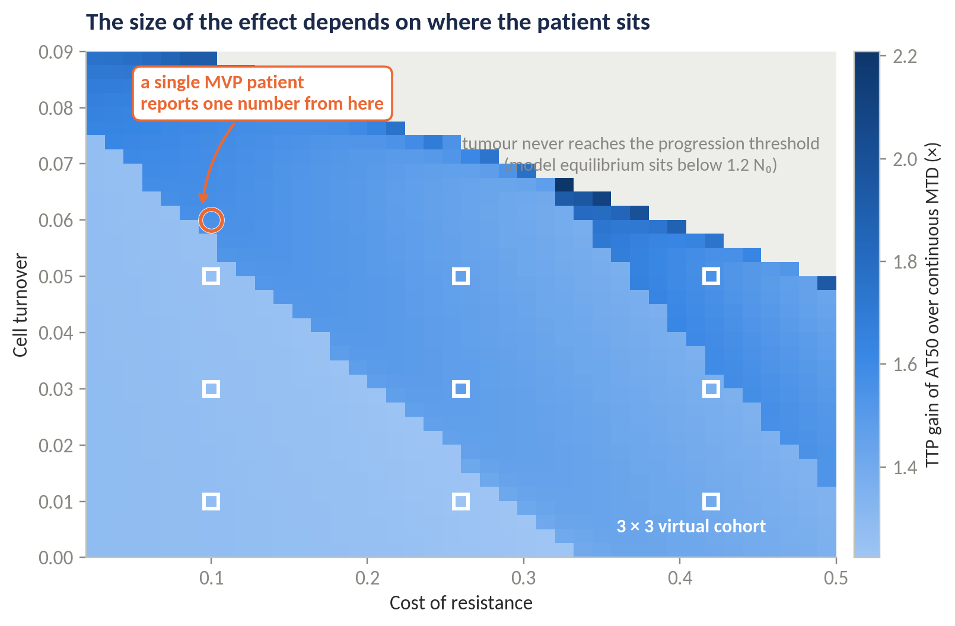
Figure 3. Our simulation of the benefit of AT50 over continuous MTD across the parameter plane. The gain ranges from 1.2× to over 2.2×, and in the grey region the tumour never reaches the progression threshold at all, so time to progression is undefined. A result reported from one patient is a result reported from one point in this picture.
The MVP therefore trains and evaluates on a 3 × 3 virtual cohort spanning cost of resistance {0.10, 0.26, 0.42} and turnover {0.01, 0.03, 0.05}, chosen to lie inside the region where progression actually occurs. This is the same parameter space Strobl and Gallagher sweep, so our robustness results remain directly comparable to theirs rather than being a private construction. Compute is genuinely not the constraint: the environment is a two-state ODE and the full grid trains on CPU within the project window.

5. The AI task, and why reinforcement learning is required
The task is sequential decision-making under a Markov decision process, not classification or regression. At each decision point the agent observes the tumour state and chooses a dose; the reward function is the variable under study.
An examiner should immediately ask why reinforcement learning is needed at all. On a two-dimensional deterministic state with a binary action, value iteration on a discretised (S, R) grid returns the exact optimal policy for any given objective — no seeds, no training instability, no variance. If that were the whole environment, the agent would be reproducing something we could already compute, and the RL would contribute nothing but noise. We take this objection seriously enough to build the project around it.
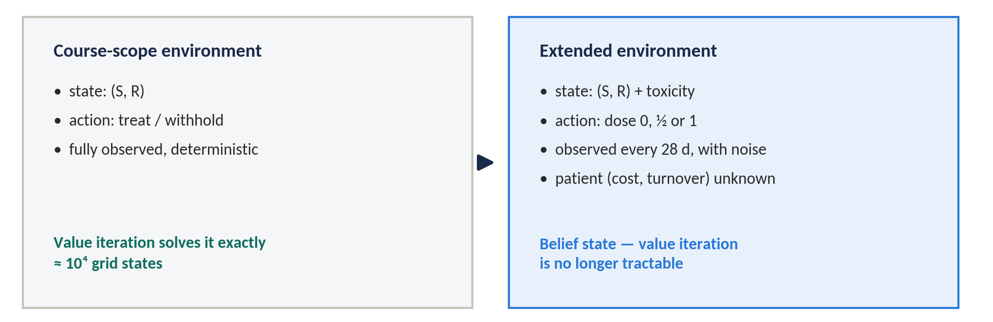
Figure 5. The environment is deliberately specified in two tiers. Value iteration is exact on the first and intractable on the second; reinforcement learning earns its place only on the second.
E-base is the fully observed, deterministic, binary-action environment. Here value iteration is tractable and we use it deliberately — not as a competitor to the agent but as a per-objective optimality ceiling, so that our claim becomes "the agent reached 96% of the computable optimum for its own objective" rather than the far weaker "the agent beat AT50".
E-ext is the environment where the question actually lives. It adds graded dosing (0, ½ or full dose rather than a binary switch), observations only every 28 days with measurement noise on the reported burden, and a patient whose cost of resistance and turnover are unknown to the agent and must be inferred from the observation history. The agent no longer acts on a state but on a belief over patient parameters, which is a continuous object; discretising it makes the state count grow exponentially in the size of the cohort and puts exact dynamic programming out of reach. Reinforcement learning is then not a stylistic preference but the only available instrument, and recurrent policies become the natural architecture (cf. Kiram et al., 2026, on partial observability in this setting).
Graded dosing matters for a second reason that is easy to miss. Under a binary action, "minimise cumulative dose" degenerates into "minimise time on treatment", which is almost exactly what a drug-holiday bonus already rewards. Several of the published objectives are only distinguishable from one another once the action space admits intermediate doses.

6. The objectives under comparison
We port two objectives from the literature. The pair is chosen not to maximise the apparent difference but to maximise what is learned from the answer.
Arm | Objective | Source | Reward terms
R1 | Survival with drug holidays — the field default and our control condition | Gallagher et al. 2023/24; replicated by Ma 2026 | +0.1 per timestep survived; +0.05 per timestep off treatment; −0.1 on progression; +5 on surviving the horizon; γ = 0.999
R4 | Durability — leaving the tumour in a controllable evolutionary state | Yao et al. 2024 | +0.1 per timestep survived; −0.1 on progression; terminal penalty on resistant-population growth over a 180-day simulated withdrawal window

Why this pair, and why the rewards share terms
R1 and R4 deliberately share an identical survival term and an identical progression penalty, and differ only in the third term — holiday bonus versus post-withdrawal regrowth penalty. This isolates the variable under study. A comparison in which the two rewards also differ in scale, discounting and structure would confound "the objective changed" with "the reward was shaped differently", and could not support the claim we want to make. We rejected a survival-versus-coexistence pairing for a related reason: a faithful port of the entropy objective to two populations places its maximum at a 50% resistant fraction, so the agent would deliberately grow resistance and divergence would be guaranteed in advance by a porting artefact rather than discovered. That variant is retained as a documented secondary result, not as the headline.
Instrumental convergence is the outcome we consider most interesting and most publishable. A durability-trained agent may well achieve longer time to progression than the agent trained directly on survival, because durability is instrumentally useful over long horizons whereas a per-step survival bonus can be myopic. If that holds, it is the paper's headline; if it fails, the null is clean and informative. Either direction answers the question.

7. Experimental plan
 | Experiment | Purpose
E0 | Reproduce the published benchmark on E-base | Correctness gate. Nothing downstream is trusted until this passes.
E1 | Baseline suite: no treatment, MTD, AT50, tuned AT-x sweep, intermittent, AT-PSC | Establishes the tuned-heuristic ceiling that RL must clear to be interesting.
E2 | Value iteration per objective on E-base | A computable optimality ceiling per objective — a column of ceilings, not one number.
E3 | Train R1 and R4 on E-ext, 10 seeds per objective per cohort patient | The agents under comparison.
E4 | Cross-evaluate every agent on every objective's metric | The core result. The content is in the off-diagonal.
E5 | Policy divergence: switching threshold N*, pairwise KL divergence | Detects policy differences that outcome metrics hide.
E6 | Cohort robustness across the 3 × 3 grid | Establishes whether the answer is patient-specific.

Our own re-implementation already lands close to the published benchmark: we obtain 454 days for continuous therapy against a published 451, and 706 days for AT50 against a published 672 — within one per cent and five per cent respectively. The residual gap is exactly what E0 exists to close, and it will be closed against the authors' published parameters rather than by tuning until the numbers agree.

Baselines and the optimality ceiling
Comparing only against continuous MTD is not sufficient when tuned heuristics and computable optima both exist. Beating MTD is treated as necessary but not sufficient — it is table stakes.
Baseline | Definition | Why it is included
No treatment | D = 0 throughout | The floor
Continuous MTD | D = D_max throughout | The universal comparator
AT50 | Dose until N < 0.5 N₀, withdraw until N ≥ N₀ | The clinical protocol as trialled
AT-x sweep | Withdrawal threshold over {25, 50, 75, 90}% | The tuned-heuristic ceiling — clearing this is a real result
Intermittent | Fixed 30 days on, 30 days off | Not response-triggered; isolates the value of feedback
AT-PSC | Partial cycle, 13 of 30 days | The current best mechanistic rule (Ma 2026)
Value iteration | Discretised (S, R) grid, solved separately per objective | The computable optimum — the strongest available comparator

8. Evaluation
Every trained agent is scored on every objective's metric, regardless of what it was trained on. Training an agent on an objective and then scoring it on that same objective's metric is circular, and a reviewer would say so in the first paragraph. The cross-evaluation is what escapes that.
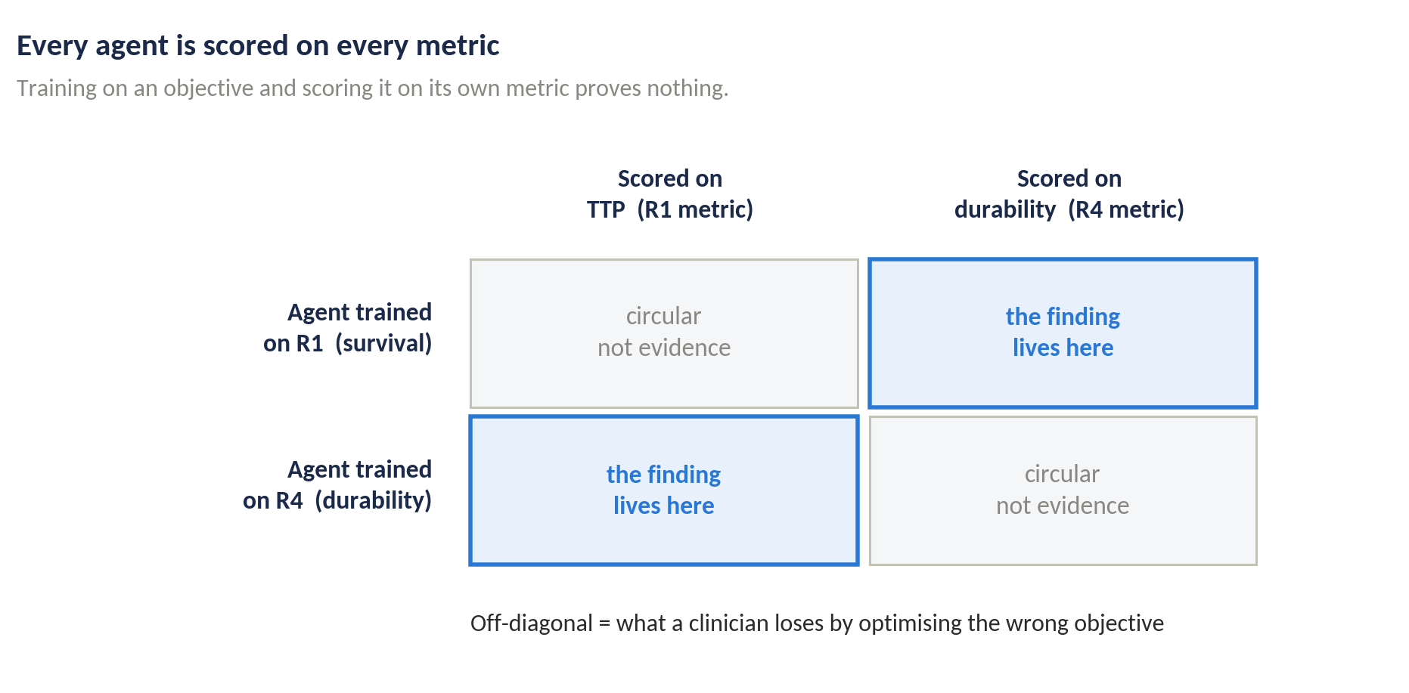
Figure 4. The cross-evaluation design. Diagonal cells are circular by construction and carry no evidential weight; the scientific content is entirely in the off-diagonal, which measures what is lost by optimising the wrong objective.
Metric | Definition | Favours
Time to progression | Days until N ≥ 1.2 N₀, checked continuously | R1
Cumulative dose | Integral of D(t), also as a percentage of MTD | —
Time off treatment | Fraction of the episode with D = 0 | R1
Mean resistant fraction | Time-average of R/N | —
Terminal resistant fraction | R/N at episode end | R4
Post-withdrawal regrowth | Growth of R over 180 untreated days after the episode | R4
Maximum burden | max N(t)/N₀ — a quality-of-life and mutation-risk proxy | neither
Switching threshold N* | Sigmoid fit to P(treat) against normalised burden | policy space
Pairwise KL divergence | Between state-action distributions over a shared state grid | policy space

What would count as a real difference
The two policy-space measures carry the divergence claim and the outcome metrics cannot substitute for them: two policies can produce near-identical time to progression while behaving quite differently in regions of state space the trajectories rarely visit, and only the switching threshold and the KL divergence will reveal that.
- Statistics. Median and the full seed distribution are reported, never the mean alone. Eastman et al. (2021) show that in this domain the advantage of RL is often near-zero variance rather than a higher peak, which the mean conceals.
- Seeds. At least ten agents per objective per cohort patient. Single-seed results in this domain are known to mislead.
- Pre-registered threshold. A cross-objective difference is claimed only if it exceeds the within-objective, seed-to-seed spread. We commit to this before seeing results.
- Success criterion. Success is explicitly not "beats MTD". A tuned heuristic and a computable optimum both exist, so the bar is the distance to the per-objective value-iteration ceiling.

9. Risks and what we do about them
Risk | Mitigation
The exact parameters reproducing the published AT50 = 672 d benchmark sit in supplementary material not present in our corpus. | Pull from the authors' public repository (MathOnco/DRL_Personalized_AT) in Week 1. Fallback: our re-implementation already matches continuous therapy to within 1%, so we proceed with a documented, self-consistent parameter set and report the benchmark gap openly rather than concealing it.
The Yao (2024) paper defining the R4 durability reward is not in our corpus, so the exact reward form is unverified. | Retrieve in Week 1, before any R4 training. If the exact form cannot be obtained, R4 is defined explicitly as our operationalisation of durability and labelled as such, not attributed to Yao.
The factor-of-two discrepancy between Strobl's and Gallagher's drug term. | Resolved in Week 1 against published code; E0 will not pass if it is wrong, which is the point of having a gate.
Progression checked only at decision points would let a fast-growing tumour progress and recover unobserved, silently overstating TTP. | Progression is checked at every integration step, not at decision points. Implemented from day one.
Raw population counts will not train. | The network is fed N/N₀ and S/K, R/K rather than absolute counts.
PPO training proves unstable on E-ext within the window. | Decision point at end of Week 4. Fall back to E-base with value iteration as the primary instrument and RL as a recovery check — a narrower but still complete and defensible result.

10. Timeline and division of work
Eight weeks, two members. The split below assigns primary ownership; both members review each other's code, and the write-up is shared.
Week | Work | Deliverable | Lead
1 | Environment implementation, parameter resolution, E0 correctness gate | Published benchmark reproduced | Arnav
2 | Baseline suite (E1); value iteration harness (E2) begun | Baseline comparison table | Arnav
2–3 | E-ext: graded dosing, observation intervals, noise, belief state | Extended environment, tested | Rohit
3–4 | PPO training harness; R1 trained, 10 seeds | R1 training stably | Rohit
5 | R4 implemented and trained, 10 seeds; value iteration completed | Both objectives trained; ceilings computed | Both
6 | Cohort runs across the 3 × 3 grid (E6); cross-evaluation (E4) | Core result matrix | Both
7 | Policy divergence (E5), statistics, figures | Divergence figure and statistics | Arnav
8 | Write-up, reproducibility package, presentation | Final report, code release, deck | Both

Software. Python with a Gymnasium-compatible environment; PPO from Stable-Baselines3 with pinned versions; ODE integration by fixed-step RK4 for reproducibility; all seeds, configuration files and parameter sets committed. The reproducibility package is itself a deliverable, since the shared environment is the artefact that makes the four-objective study feasible beyond this course.

11. Expected outcomes and limitations

What we expect to deliver
- A quantified answer — supported in either direction — to whether the choice of reward objective changes an adaptive-therapy policy in this model class, and by how much.
- A correctness-verified, shared environment in two tiers, with two ported objectives, per-objective value-iteration ceilings, and a reproducible cross-evaluation pipeline that extends to the remaining objectives beyond this course.
- A documented, falsifiable null-result path: if the objectives converge, that is reported as the finding rather than buried.

What we do not claim
- No clinical applicability. This is a simulation study on a virtual cohort; no real patient data is used and no treatment recommendation follows from it.
- Two objectives of at least four are compared, on a nine-patient virtual cohort. The remaining objectives — dose-and-time penalty, coexistence, toxicity — are ported but not trained within the eight weeks.
- The model omits spatial structure, pharmacokinetics, phenotypic switching and de novo mutation. Resistance is pre-existing, binary and irreversible by assumption.
- A tumour with only two subpopulations cannot represent doubly resistant phenotypes; that requires a higher-dimensional simplex and is named future work.

The translational path, stated plainly
For this line of work to inform a trial, three things would have to become true: the environment would need to be fitted to longitudinal patient biomarkers rather than to a parameter grid, the policy would need to be validated against held-out patients rather than against its own simulator, and the objective itself would have to be chosen in consultation with clinicians rather than inherited from a previous paper. The last of those three is what this project is about, and it is the one that can be settled in silico. West et al. (2023) pose exactly this question — what should the control target be — in their survey of open problems in the field.

12. References
Gatenby RA, Silva AS, Gillies RJ, Frieden BR. Adaptive therapy. Cancer Research. 2009;69(11):4894–4903.
Zhang J, Cunningham JJ, Brown JS, Gatenby RA. Integrating evolutionary dynamics into treatment of metastatic castrate-resistant prostate cancer. Nature Communications. 2017;8(1):1816.
Zhang J, Cunningham J, Brown J, Gatenby R. Evolution-based mathematical models significantly prolong response to abiraterone in metastatic castrate-resistant prostate cancer and identify strategies to further improve outcomes. eLife. 2022;11:e76284.
Strobl MAR, West J, Viossat Y, Damaghi M, Robertson-Tessi M, Brown JS, Gatenby RA, Maini PK, Anderson ARA. Turnover modulates the need for a cost of resistance in adaptive therapy. Cancer Research. 2021;81(4):1135–1147.
Gallagher K, Strobl M, Gatenby R, Maini P, Anderson A. Learning to adapt — deep reinforcement learning in treatment-resistant prostate cancer. bioRxiv. 2023. doi:10.1101/2023.04.28.538766
Gallagher K, Strobl MAR, Park DS, Spoendlin FC, Gatenby RA, Maini PK, Anderson ARA. Mathematical model-driven deep learning enables personalized adaptive therapy. Cancer Research. 2024.
Gluzman M, Scott JG, Vladimirsky A. Optimizing adaptive cancer therapy: dynamic programming and evolutionary game theory. Proceedings of the Royal Society B. 2020;287(1925):20192454. [optimal control, not reinforcement learning]
Weaver DT, King ES, Maltas J, Scott JG. Reinforcement learning informs optimal treatment strategies to limit antibiotic resistance. PNAS. 2024;121(16):e2303165121.
Eastman B, Przedborski M, Kohandel M. Reinforcement learning derived chemotherapeutic schedules for robust patient-specific therapy. Scientific Reports. 2021;11:17882.
Reinforcement learning for chemotherapy scheduling in a stochastic tumor evolution model. Physical Review E. 2026;113:064404. doi:10.1103/cbkw-5s4b [entropy / coexistence objective]
Kiram FME, et al. Recurrent deep reinforcement learning for chemotherapy control under partial observability. arXiv:2605.02552. 2026.
Wang M, Scott JG, Vladimirsky A. Threshold-awareness in adaptive cancer therapy. PLOS Computational Biology. 2024;20(6):e1012165.
Viossat Y, Noble R. A theoretical analysis of tumour containment. Nature Ecology & Evolution. 2021;5(6):826–835.
West J, Adler F, Gallaher J, Strobl M, Brady-Nicholls R, Brown J, Robertson-Tessi M, Kim E, Noble R, Viossat Y, et al. A survey of open questions in adaptive therapy: bridging mathematics and clinical translation. eLife. 2023.
Yao et al. Durability-oriented reward design for adaptive therapy. Briefings in Bioinformatics. 2024. [to be verified in Week 1 — see §9]
Ma et al. AT-PSC: a partial-cycle adaptive therapy protocol. PLOS Computational Biology. 2026;22(6):e1014457.
Gevertz JL, et al. Toxicity-aware adaptive therapy scheduling. npj Systems Biology and Applications. 2026;12:11. [not in corpus — optional fifth objective]

